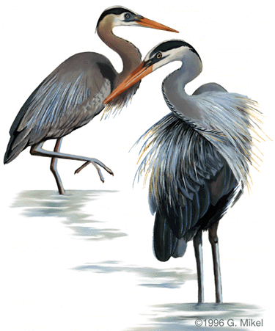

The Herron Files

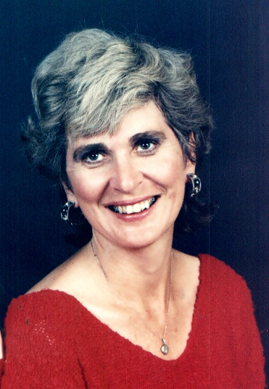

Patricia Herron
Home & 1145 Waller St SE
Studio Salem, Or 97302
503 399-9338

Patricia Herron was born in LaGrande, Oregon and gained formal training in life drawing and water color courses at Eastern State University, LaGrande, Oregon. She also took private oil painting from Eastern Oregon Artist Millie Boyd, who now resides in Salem, Oregon.

Prior to formal study Patricia had enjoyed painting in an existential, loose painterly style in hopes of capturing the mystery of excellence.

These years also encompassed Patricia’s most formative life experience: the struggle and heartache of being a single parent, with four young children. This was the setting for her years of art and study.

Patricia also teaches Philosophy and Literature. She has taught courses at Oregon State University in the Honor’s Program and Philosophy part time at Marylhurst University. Currently she is teaching part time at Chemeketa College in Salem, Or. Patricia’s philosophical thinking and achievements have produced questions concerning the direction of art as a return to the final destination of the artist within us, to touch the soul, the roots, the origin.

Gallery Affiliations

May- Pegasus Gallery (single painting)
June 341 SW 2nd
1992 Corvallis, Or 97333

July Pegasus Gallery (one artist show)
1992 341 SW 2nd
Corvallis, Or 97333

Jan Schubert Gallery
1993 103 Main SE
Albany, Or 97321

Nov 1993- Pegasus Gallery (4 paintings)
Jan 1994 341 SW 2nd
Corvallis, Or 97333

Feb 1995- Citizens Bank (40 paintings)
Feb 1996 275 SW 3rd
Corvallis, Or 97330

Nov 1993- Governor’s Cup (30 paintings)
Mar 1996 Court Street
Salem, Or

Jan-July Tambra Gallery (6 paintings)
- 222 Commercial Street

April- The Oasis Restaurant (20 paintings)
May Ground Floor State Capitol
1994 Salem, Or 97310

July 1994 Pegasus Gallery (10 paintings)
341 SW 2nd
Corvallis, Or 97333

Jan-May Angel Gallery
1996 3257 SE Hawthorne Blvd
Portland, Or 97330

April- The Oasis Restaurant (20 paintings)
May Ground Floor State Capitol
1996 Salem, Or 97310

Dec 1995 Pegesus Gallery
& Dec 341 SW 2nd
1996 Corvallis, Or 97333

Aug Shoen Library
1996 Streff Gallery
Marylhurst, Or

Salem, Or
Aug Shoen Library
- Streff Gallery
Marylhurst, Ore

Collections

Private: Darrell Roberts, Corvallis, Or; Don & Marcia Emenaisen, Corvallis, Or; Usha Honeyman, Corvallis, Or; Loren & Flo Leibowitz, Corvallis, Or; Karl Hase, Longmont, Co; Ward & Lynn Rouse, Turner, Or; Betty Ragsdale, LaGrande, Or; Sr. Francis Madden, Mt Angel Seminary, Mt Angel, Or; Virginia Rice, Springfield, Or; Jim & Margaret McClure, Elgin,Or; Walter & Theresa Beery, LaGrande, Or; Katie Ludwig, Elgin, Or; Helen Jagelski, Bozeman, Mt; Kathy Smith, Corvallis, Or; Anita Sullivan, Corvallis, Or; Don Doles, Imbler, Or; Barbara Weaver, Elgin, Or; Harry Hunt, LaGrande, Or; Bill Stratton, Salem,

